Inventory levels research:

* “driven not only by the number of COVID-19 cases but also by misinformation, panic buying, and stockpiling − will result in further shortages of PPE globally. “ [link](https://apps.who.int/iris/bitstream/handle/10665/331498/WHO-2019-nCoV-IPCPPE_use-2020.2-eng.pdf)

List of inventory list [WHO](https://apps.who.int/iris/bitstream/handle/10665/331498/WHO-2019-nCoV-IPCPPE_use-2020.2-eng.pdf):

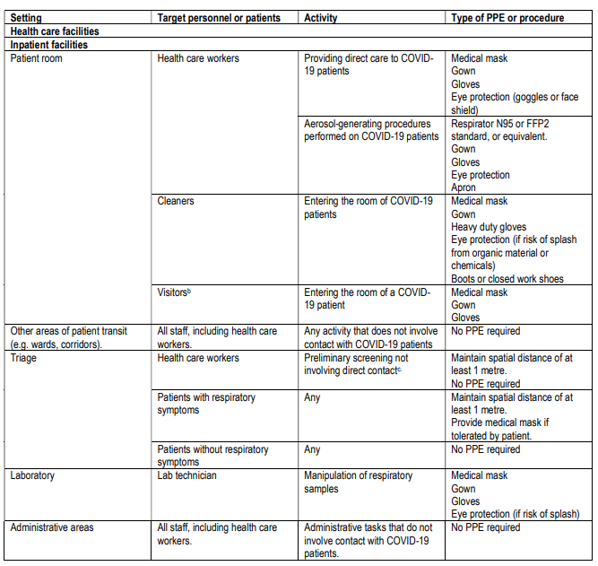

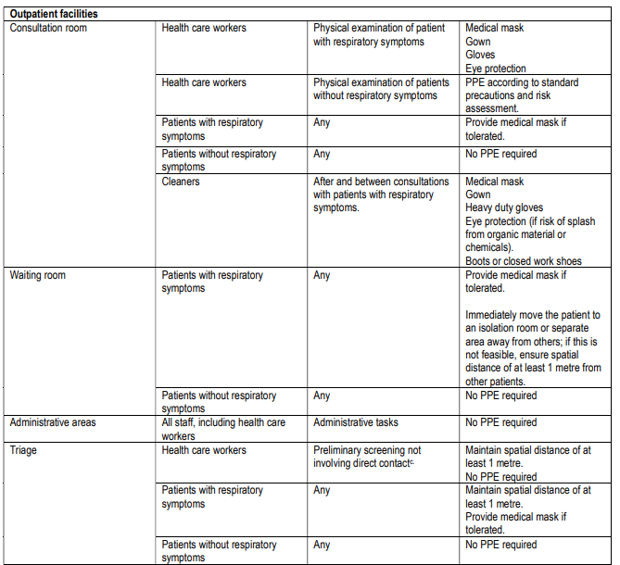

In addition to the PPE other critical items: [link](https://www.nejm.org/doi/full/10.1056/NEJMp2006141)

* Ventilators
  + Some forecast that it will require 1M, but currently needs 100k
    - Note: See the current inventory of ventilators in the US, hypothesis is that there is enough currently to help tackle the most in need
* Masks
* Hand sanitizer
* Other insights:
  + ‘Construction companies, laboratories, artists, and even the sets of some television shows have stores of these items.’

To Do:

* Research the standards that FDA has approved for N95, there are other manufactures in the US that produce millions a month.
  + Idea: maybe have a inventory list and ranked by the quality of the N95? Save the highest quality to the most in need? And re route?
* Financial issues… financial